Assignment 2 – data testing

Ping tests:

1. lab → pi, 10 times 0.2s interval
--- 192.168.10.2 ping statistics ---
10 packets transmitted, 10 received, 0% packet loss, time 1836ms
rtt min/avg/max/mdev = 0.433/0.476/0.511/0.019 ms

2. pi → lab, same conditions as above
--- 192.168.10.1 ping statistics ---
10 packets transmitted, 10 received, 0% packet loss, time 1841ms
rtt min/avg/max/mdev = 0.402/0.530/0.646/0.072 ms

3. pi → lab, 100 times, 0.001s interval
--- 192.168.10.1 ping statistics ---
100 packets transmitted, 100 received, 0% packet loss, time 99ms
rtt min/avg/max/mdev = 0.308/0.348/0.550/0.031 ms

the mean is much closer to the minimum than the maximum. This is different to the first two tests where the mean was close to between the min and max.
This is likely due to the fact that we are running more tests so there is a higher likelihood that a ping is sent during a time of high congestion, high packet loss or when other high priority signals are being sent. This will mean our signal will have to wait a bit before being sent therefore increasing the ping in some cases as can be seen in the max case.

4. pi → lab, 10000 times, with flooding
--- 192.168.10.1 ping statistics ---
10000 packets transmitted, 10000 received, 0% packet loss, time 3337ms
rtt min/avg/max/mdev = 0.161/0.299/0.495/0.024 ms, ipg/ewma 0.333/0.297 ms

5.
CDF for 0.01s interval
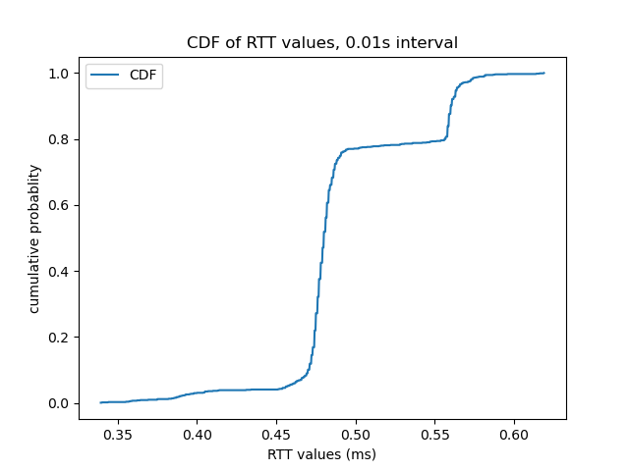
0.001s interval
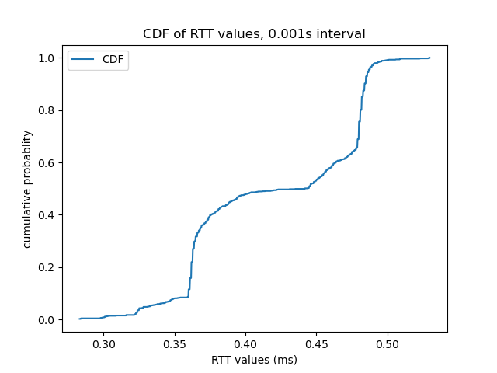
0.0001s interval

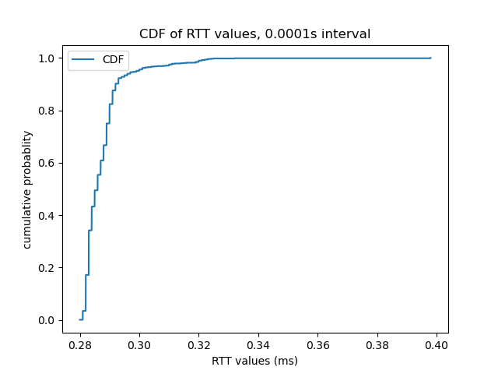
6.
Ping provides an upper-bound value for the RTT as it also takes into consideration, and measures the time taken to get a path for our ping message to be relayed through. This time can be quite significant due to factors such as network congestion, prioritization, latency and packet loss. When running at higher time intervals, there is a greater chance of encountering these situations which will increase the ping times therefore increasing the max and mean times and skewing the CDF to the right.
This means that the most accurate RTT would probably be the minimum time.

Iperf Tests:

1. lab machine as server, pi as client. 10 sec experiment
[ ID] Interval Transfer Bandwidth
[ 3] 0.0000-10.0030 sec 1.10 GBytes 0.941 Gbits/sec

2.

[ ID] Interval Transfer Bandwidth
[ 1] 0.0000-1.0000 sec 0.111 GBytes 0.954 Gbits/sec
[ 1] 1.0000-2.0000 sec 0.110 GBytes 0.944 Gbits/sec
[ 1] 2.0000-3.0000 sec 0.110 GBytes 0.942 Gbits/sec
[ 1] 3.0000-4.0000 sec 0.110 GBytes 0.942 Gbits/sec
[ 1] 4.0000-5.0000 sec 0.109 GBytes 0.937 Gbits/sec
[ 1] 5.0000-6.0000 sec 0.110 GBytes 0.942 Gbits/sec
[ 1] 6.0000-7.0000 sec 0.110 GBytes 0.942 Gbits/sec
[ 1] 7.0000-8.0000 sec 0.110 GBytes 0.942 Gbits/sec
[ 1] 8.0000-9.0000 sec 0.110 GBytes 0.943 Gbits/sec
[ 1] 9.0000-10.0000 sec 0.110 GBytes 0.945 Gbits/sec
[ 1] 0.0000-10.0324 sec 1.10 GBytes 0.940 Gbits/sec

